Steps to Process Failed Transactions
- Open eTreasury @ https://ifms.punjab.gov.in by entering https://ifms.punjab.gov.in link into address bar of your browser and click on eTreasury tabbutton as shown in the screenshot given below: 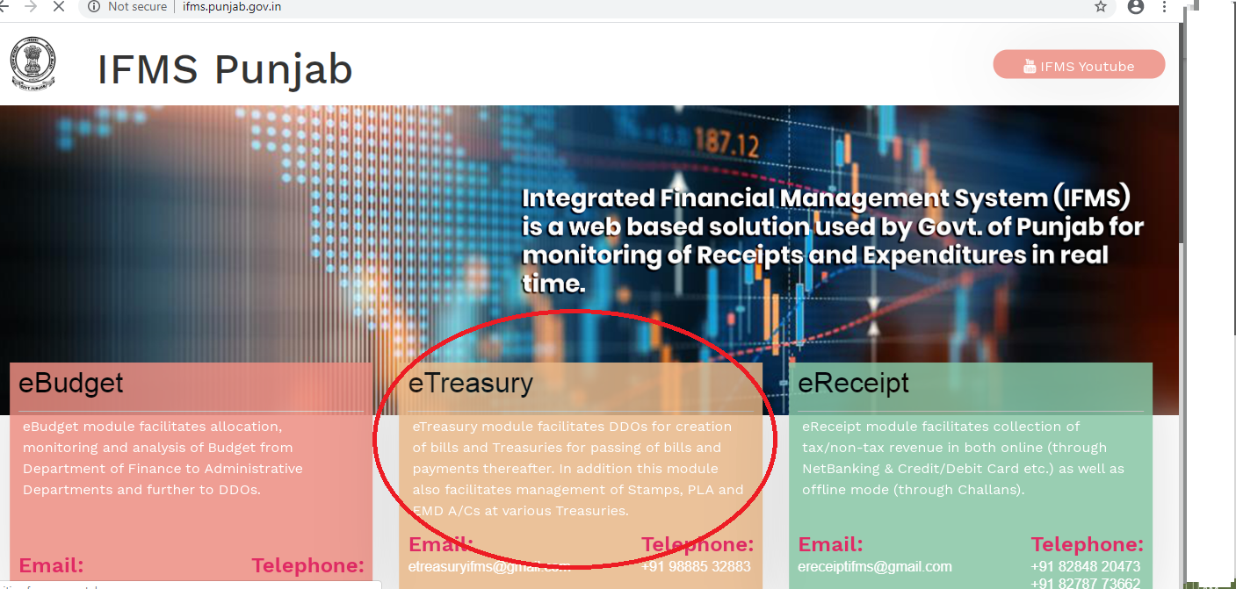

- DDO needs to login into the system by entering provided credentials on the screen as shown below:
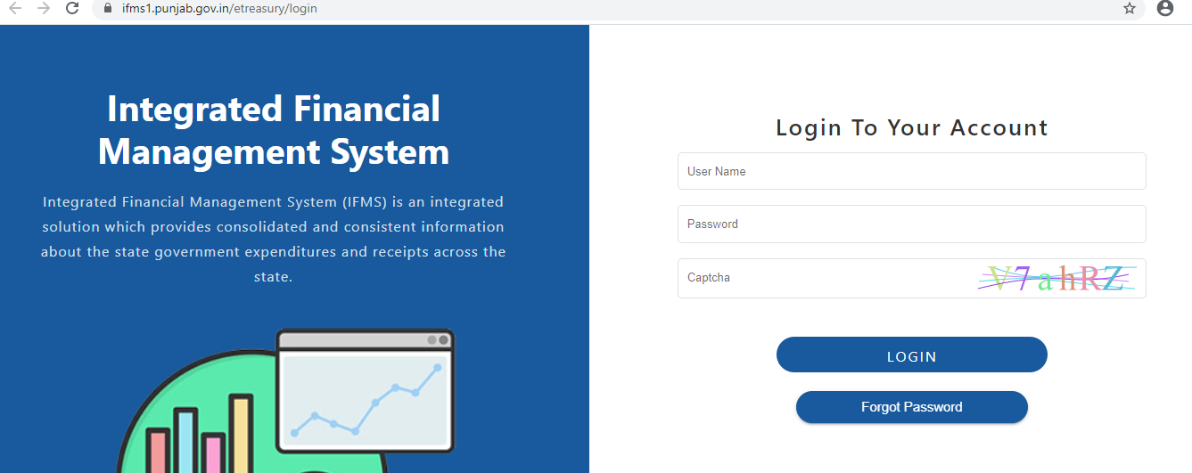

- Click on Failed Transactions link as shown in the screenshot given below:
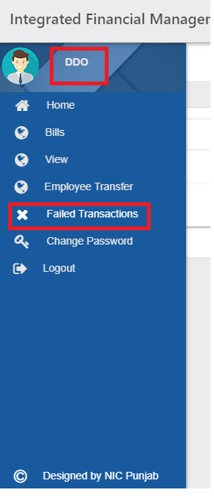

- On clicking Failed Transactions link, system will show all failed transactions in DDO’s login with status against them as shown below, here click Rectify button on the screen as shown below: System is showing failed transaction records as Payee wise, means if there would be any wrong detail entered against the particular payee then on updating the details it will get corrected in all the bills created for that payee.

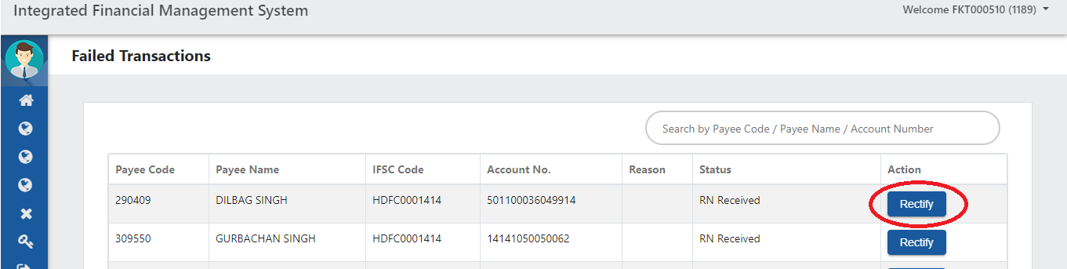

- On clicking Rectify button, screen will display Payee Details. Enter the correct IFSC Code, Account No. and Upload Scanned Copy of Passbook/Cancelled Cheque on the screen as shown below:
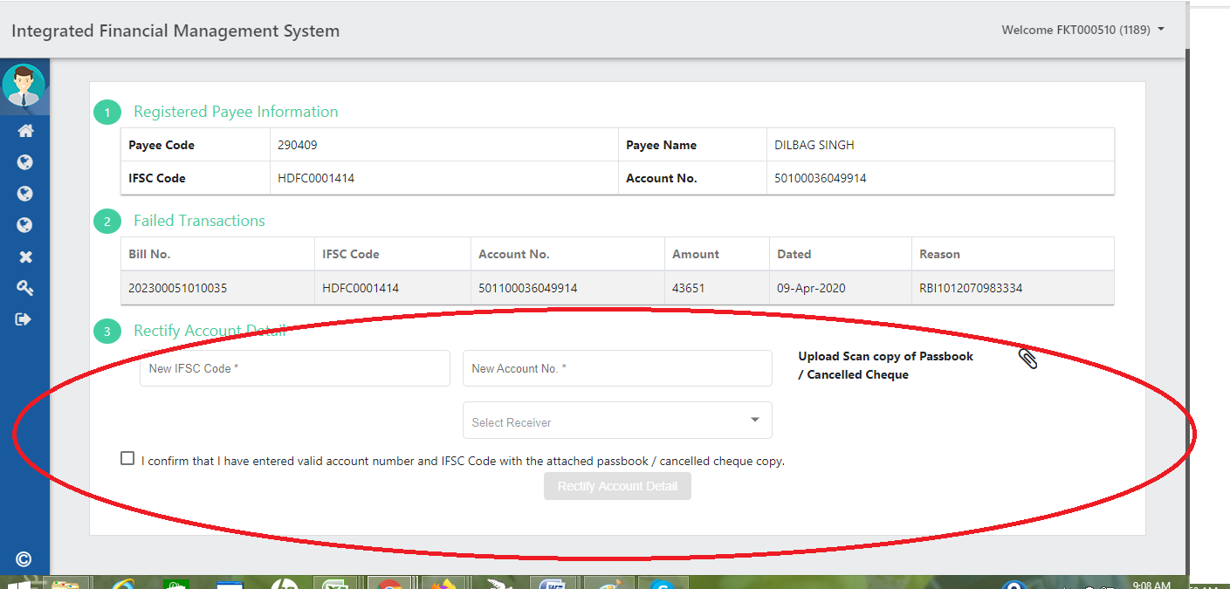

- After filling and uploading details, select Receiver to whom you want to forward the details for further processing (either DTO/TO).
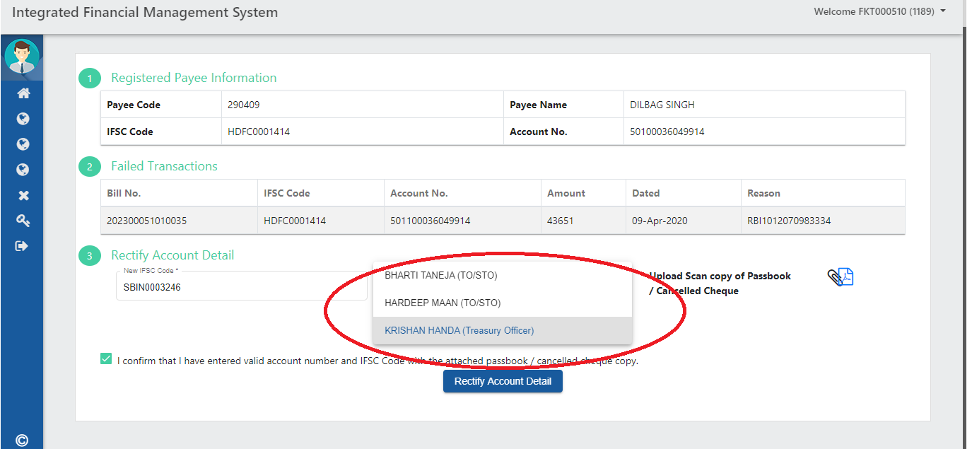

- Once Receiver selected, click on the Rectify Account Details button to submit the details to Treasury.
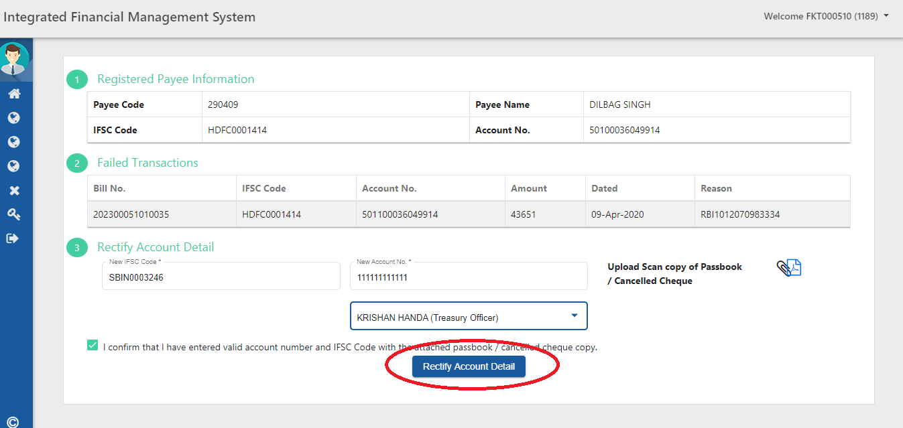

- On clicking Rectify Account Details button, system will ask for OTP that would be received at DDO’s registered mobile number.
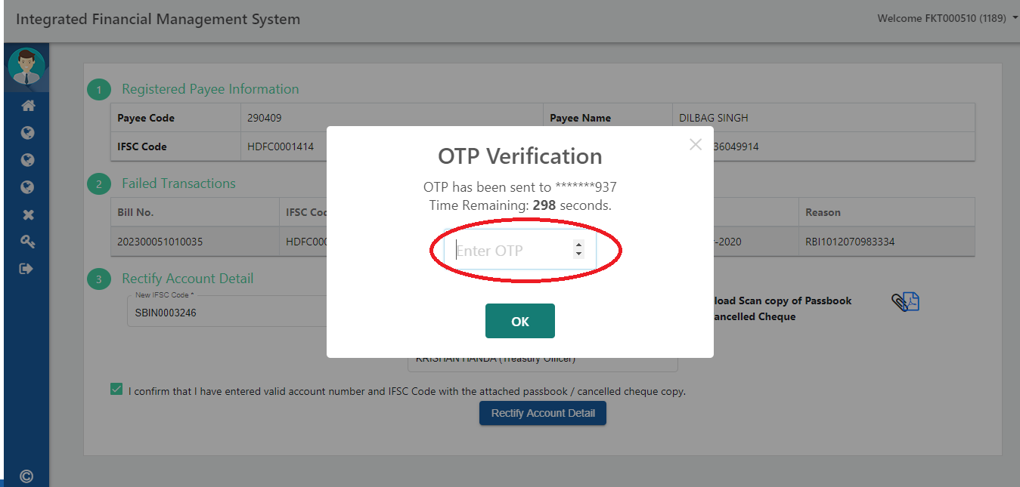

- After entering the OTP received, the details will get forwarded to DTO/TO with following message:
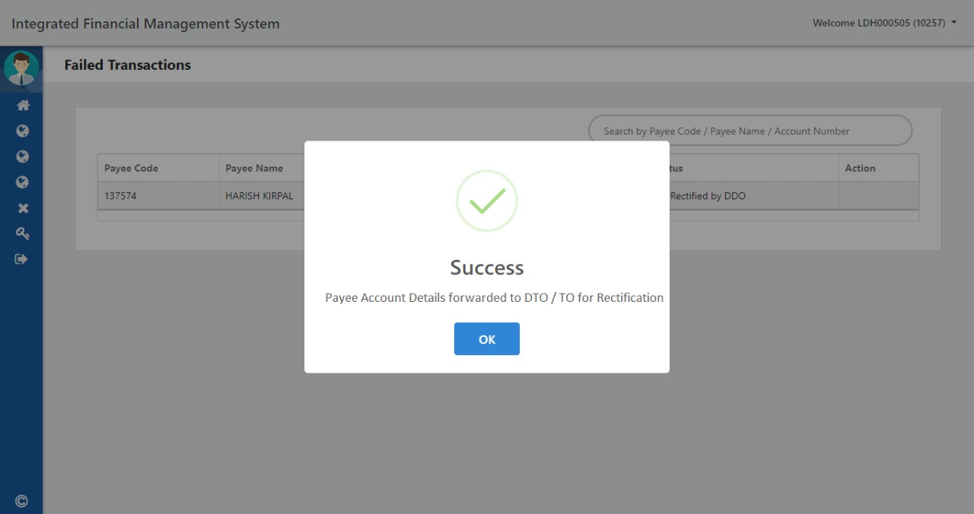

- Status will get changed to RN Rectified by DDO, means the record forwarded to Treasury for approval.

- Treasury user (DTO/TO) will login into the system and click on Failed Transactions link as shown below: 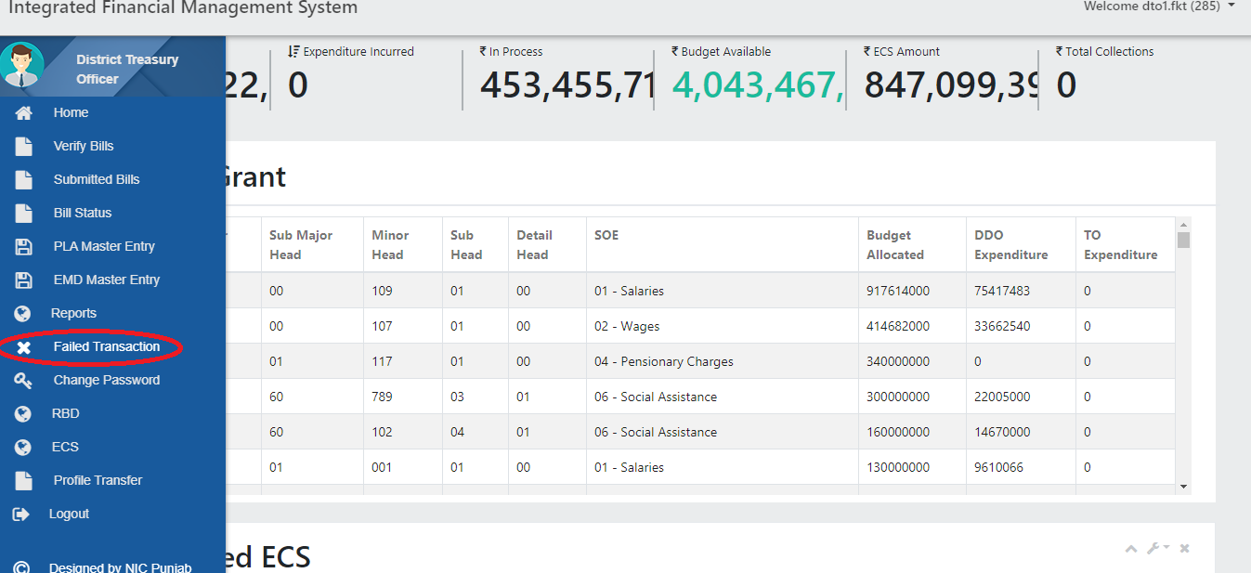

- It will show all Failed Transactions as shown below, please note that if DDO has rectified the Return Note record then Process button will be shown in front of that record as shown below, click this Process button:

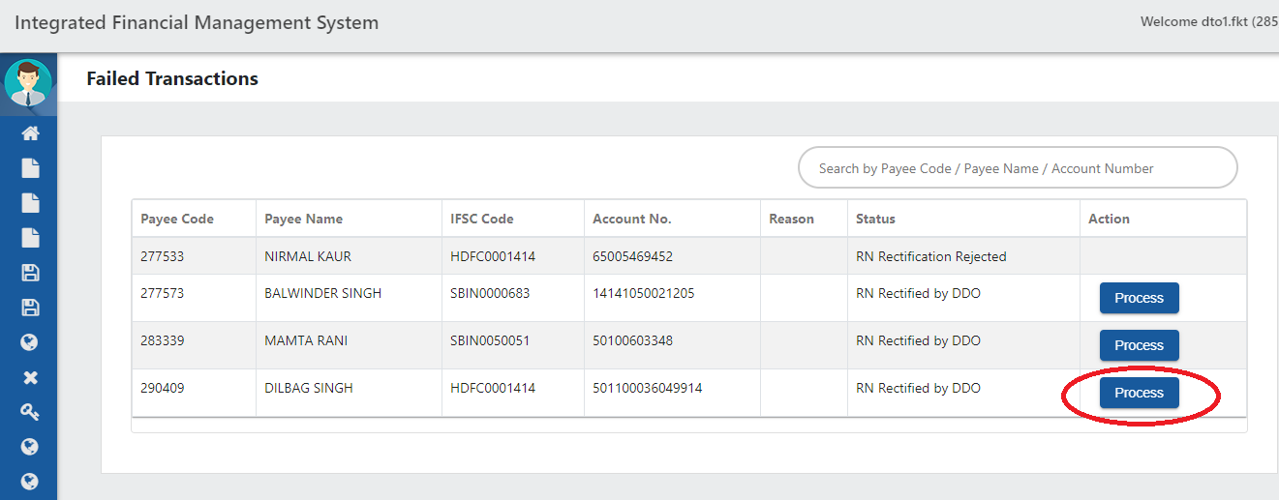

- It will show screen as shown below, here DTO/TO can view A/C No. and IFSC Code and can verify it by clicking at Passbook Copy/Cancelled Cheque link as shown below:
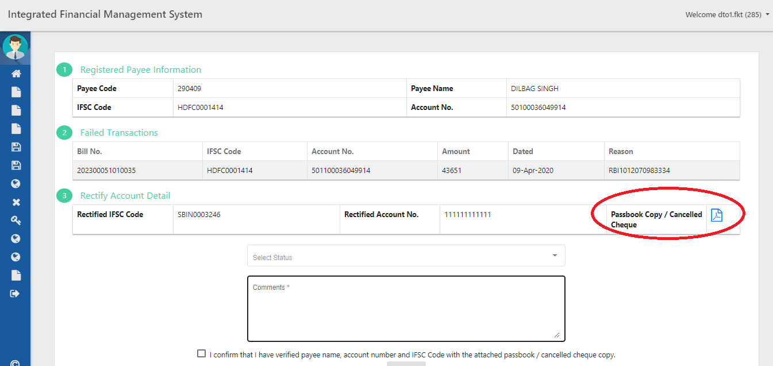

- DTO/TO can Approve (by selecting Rectification Approved) or Reject ( by selecting Rectification Rejected) the record by confirming it by seeing attached documents .
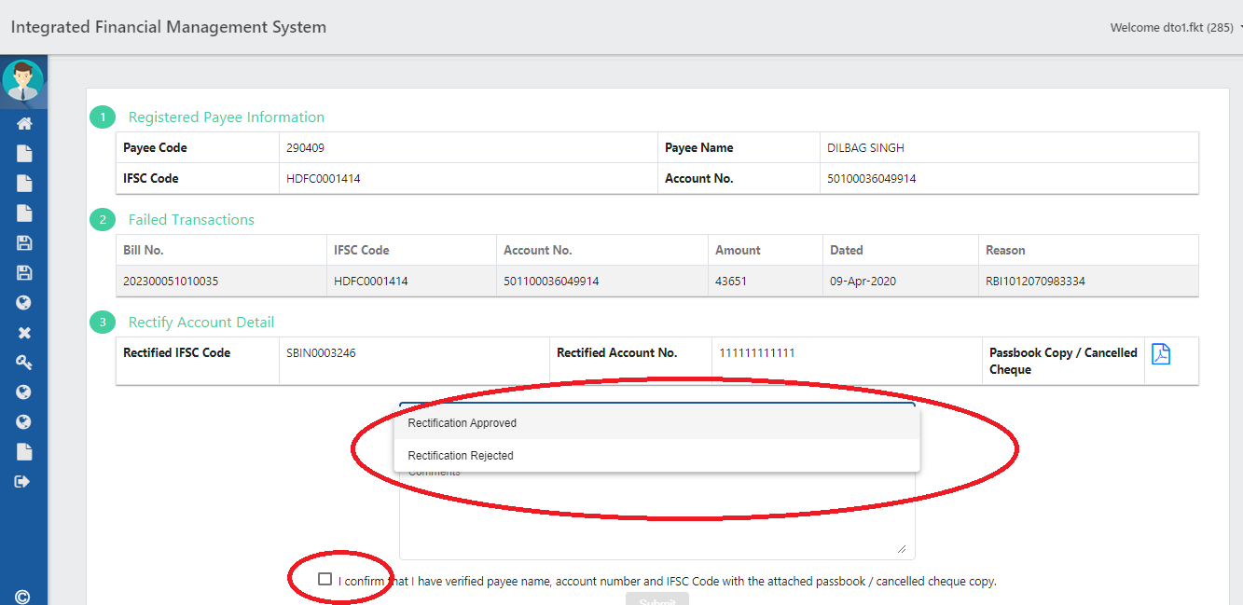

- Select one option as Rectification Approved selected and click Submit button on the screen as shown below:
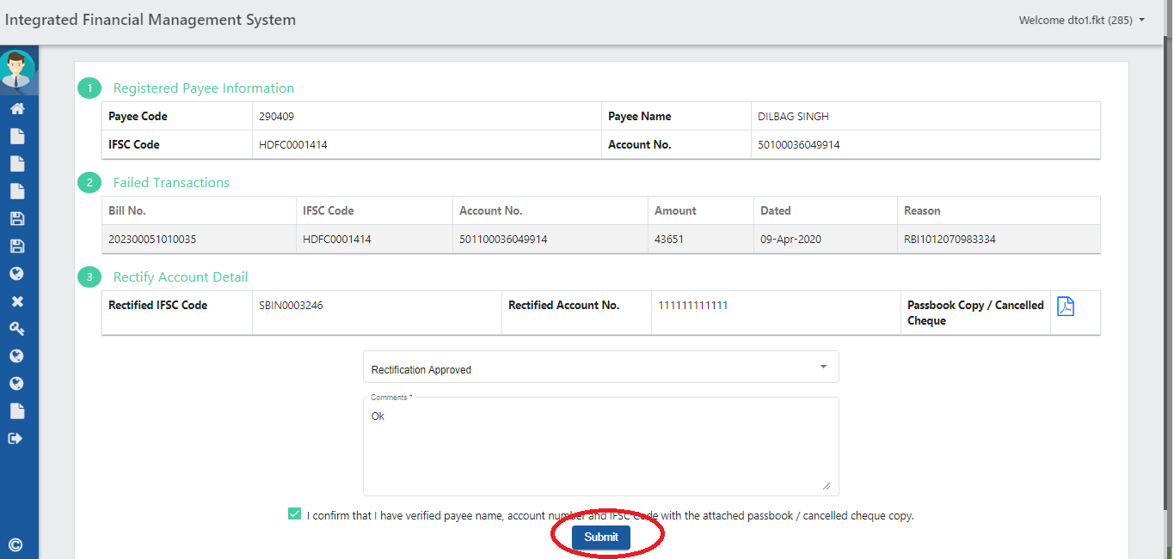

- It will display following message “Payee Account Details Rectified Successful” :
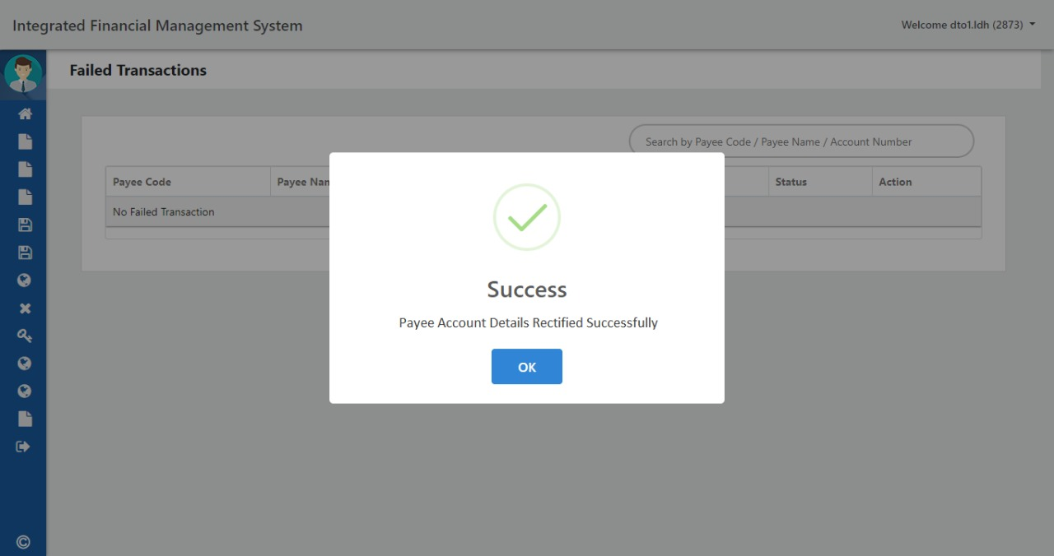

- After approving the records, DTO/TO need to make ECS file for Rectified Records by clicking Prepare RN ECS as shown below:
It will not impact the regular workflow of payments and will only minus from suspense head and it’s just a transaction to make the payment to user.
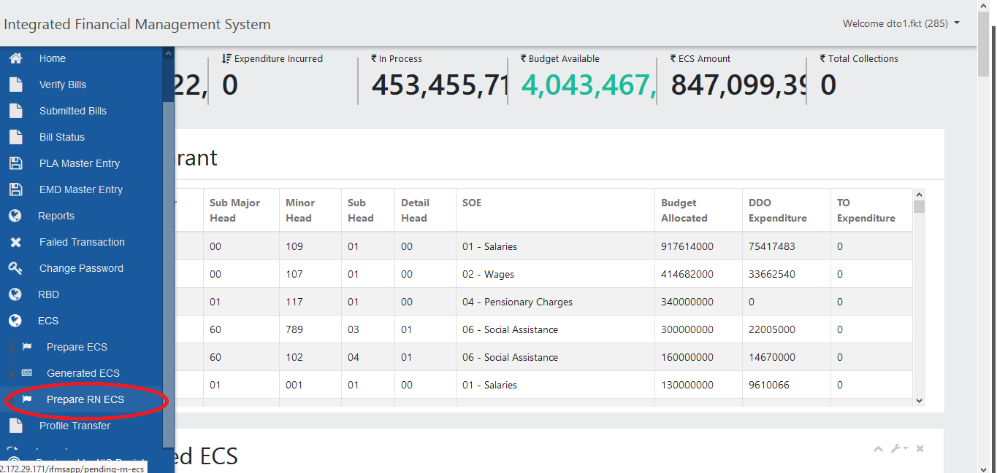

- The system will show the bills against which the records approved by the DTO/TO. Select the respective bills for which ECS needs to be created and click on Prepare ECS File button on the screen as shown below:
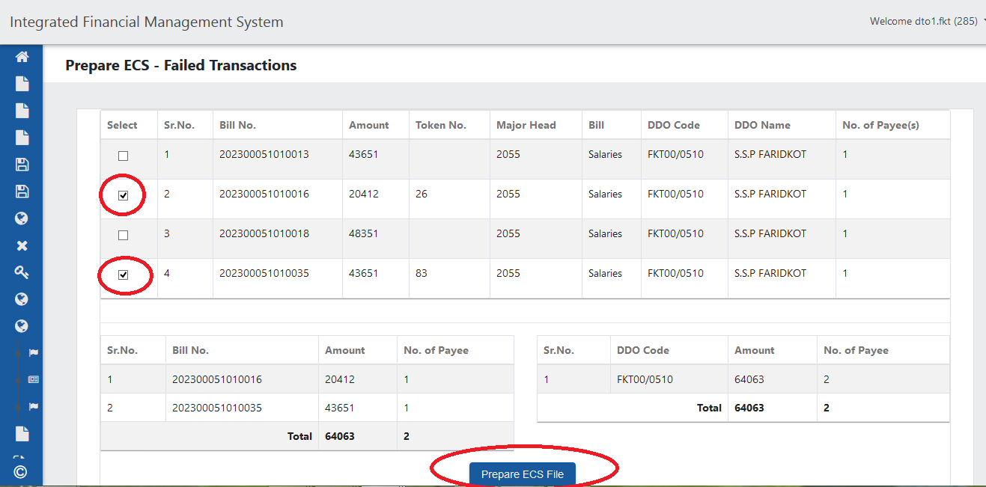

- On clicking Prepare ECS File button, the system will show following alert, click Yes to proceed further on the screen as shown below:

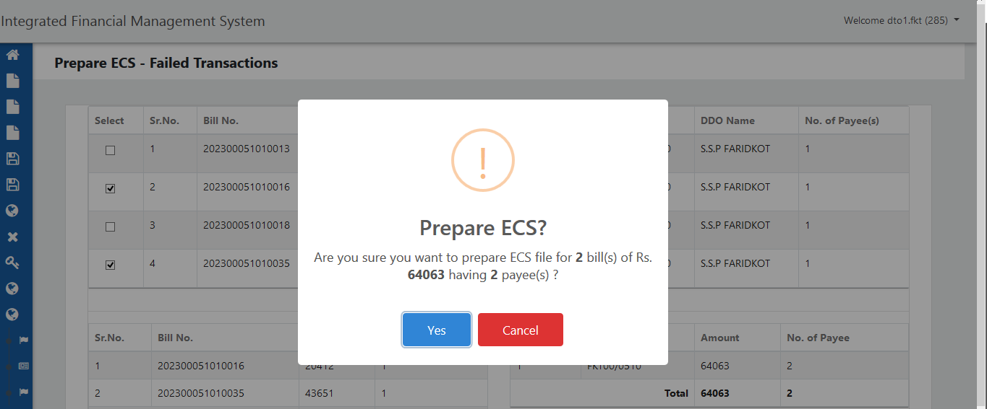

- The system will confirm ECS creation with following alert message:
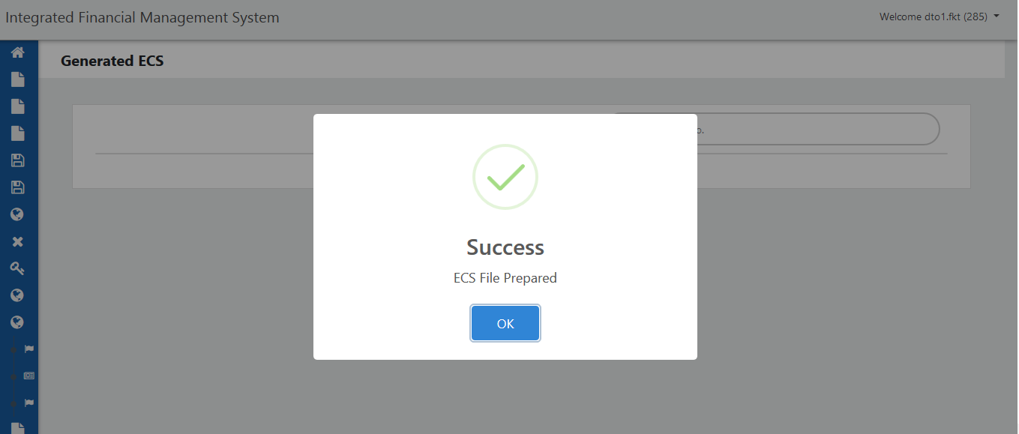

- On the other way, DTO/TO can reject the record by selecting Rectification Rejected option on the screen as shown below:
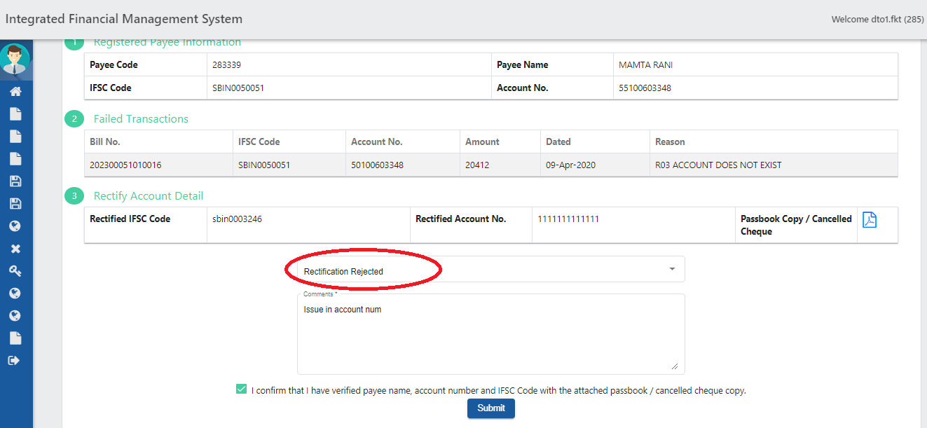

- Once rejected, the system will show status as RN Rectification Rejected and record will send back to DDO Dashboard.
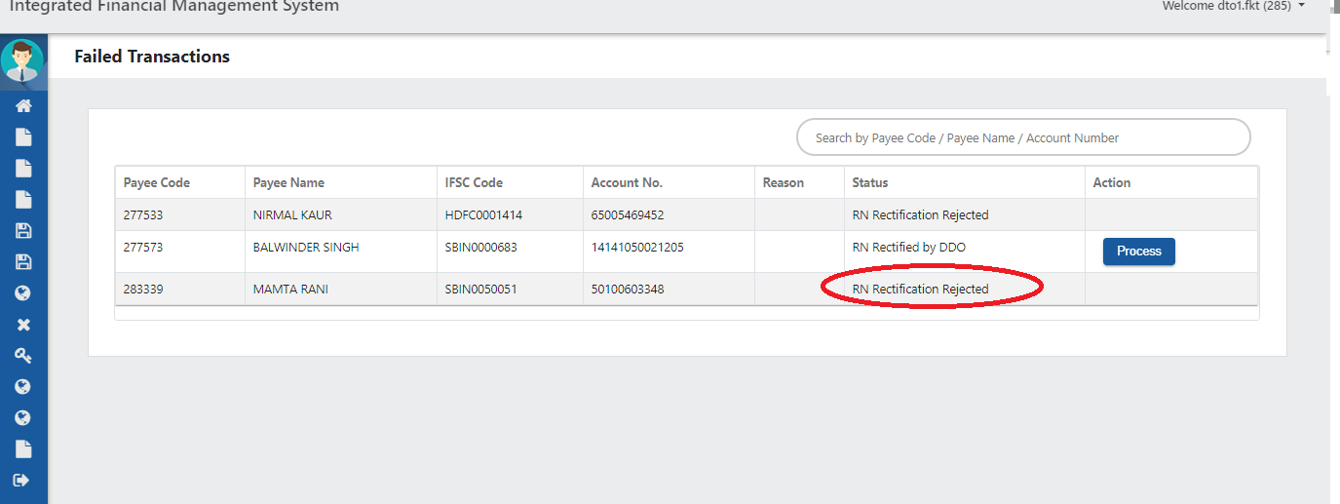

- At DDO’s dashboard, rejected RN will be seen as shown below, here DDO needs to click Rectify button for rectification:

- Rejection reason by DTO/TO will be shown on the screen as shown below, DDO needs to rectify the record accordingly.
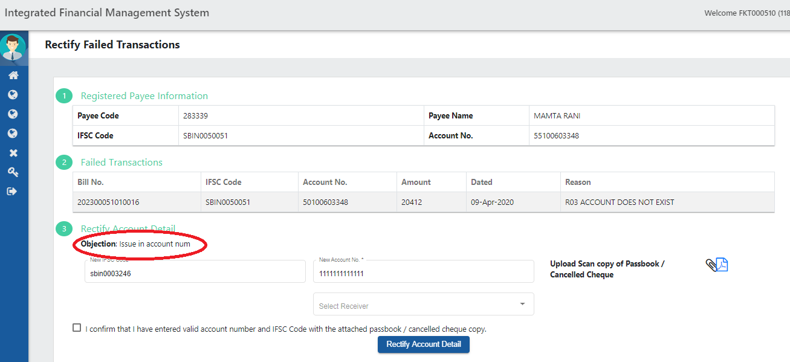

- Click on Rectify Account Details button after updating the required details.

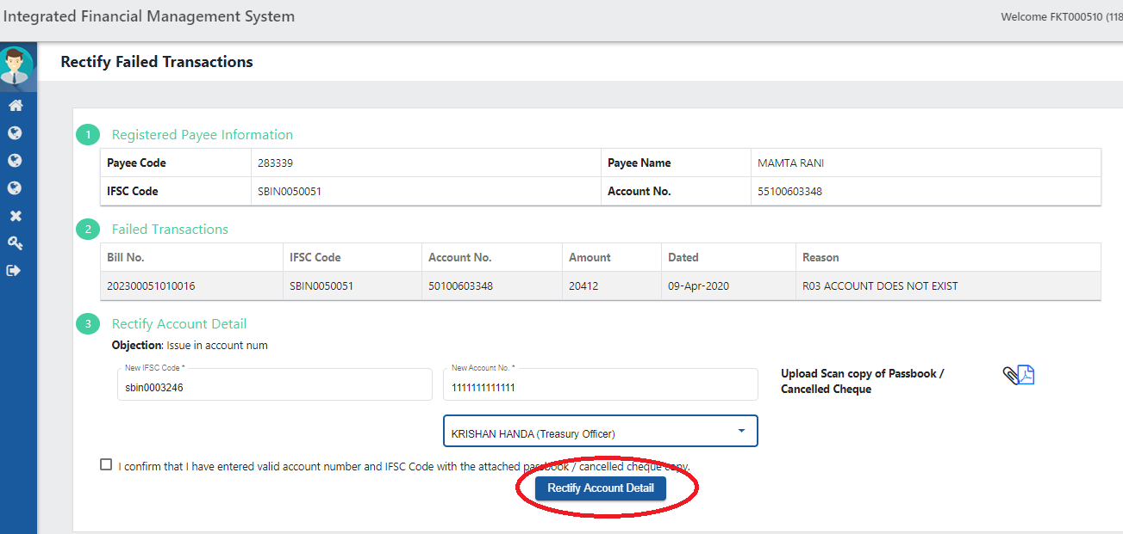

- System will give following message on successful submission to Treasury.

- Failed Transactions Report will be available soon in which DDO’s/DTO’s can track the failed transactions status at any time.

