Steps To Transfer Employee from Other to Regular category

- Click on View Payee link on left menu bar, it will show all Registered Payees under the DDO, then click on Red Pen Icon in front of employees in Other category.
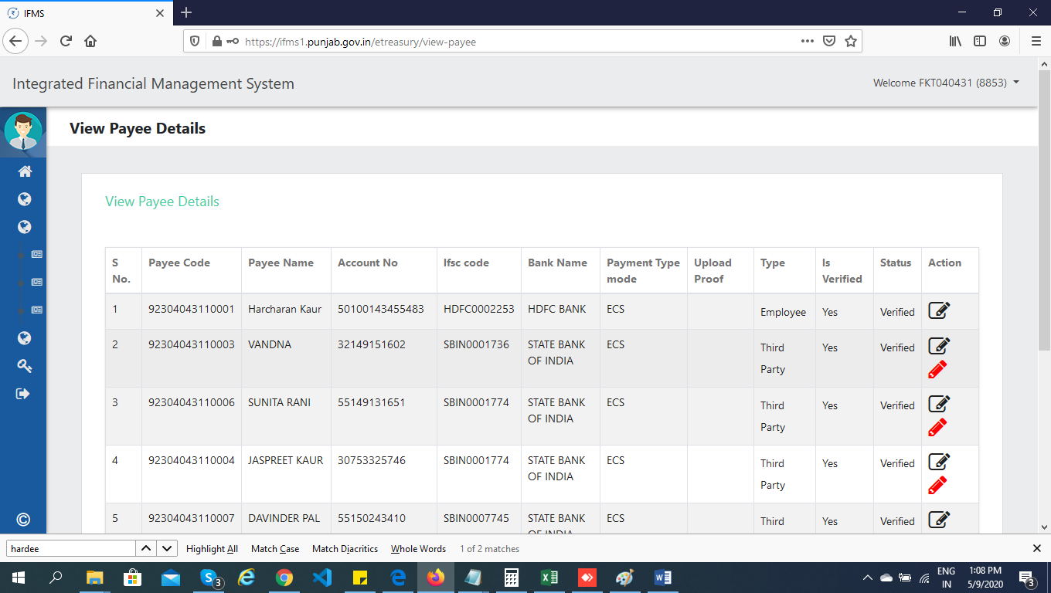

- Once clicked, a window will be shown to change the employee type. Select Transfer Type as Regular and enter HRMS Employee code as shown in screenshot give below:

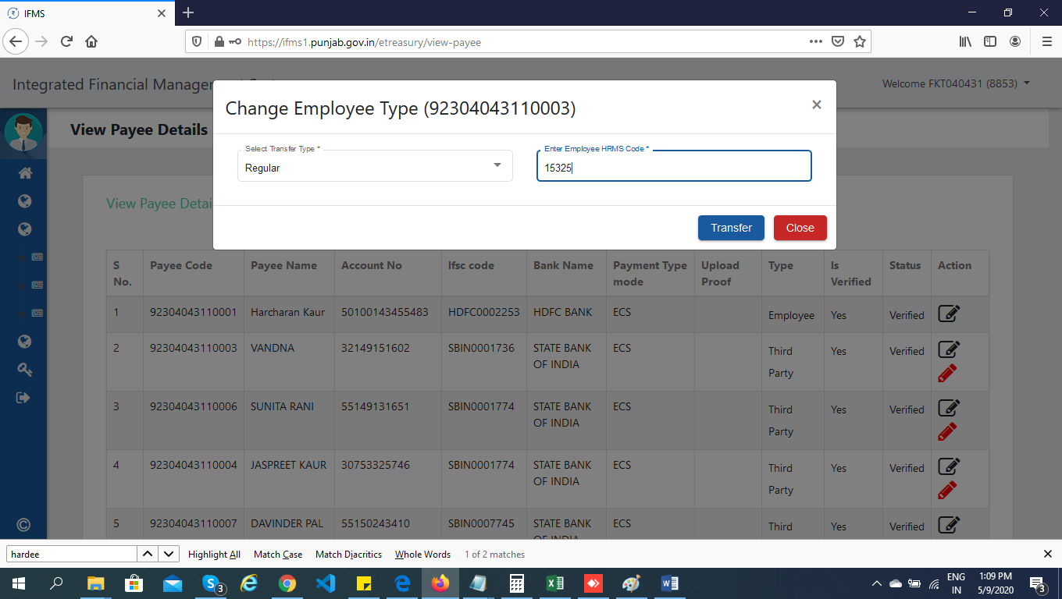
- In case HRMS Employee Code employee not mapped with the DDO, then an alert message will be shown as given below and use Employee Transfer screen for the same.
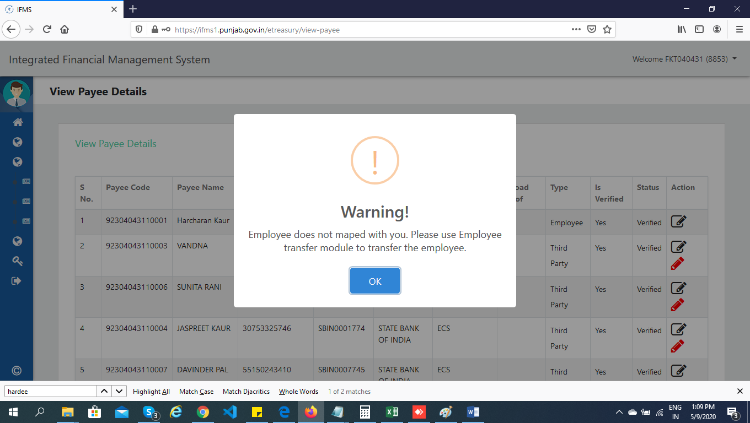

- Click on Employee Transfer Request For Transfer link as shown below to transfer the Employee by selecting Transfer Type as Regular and entering the HRMS Employee Code.
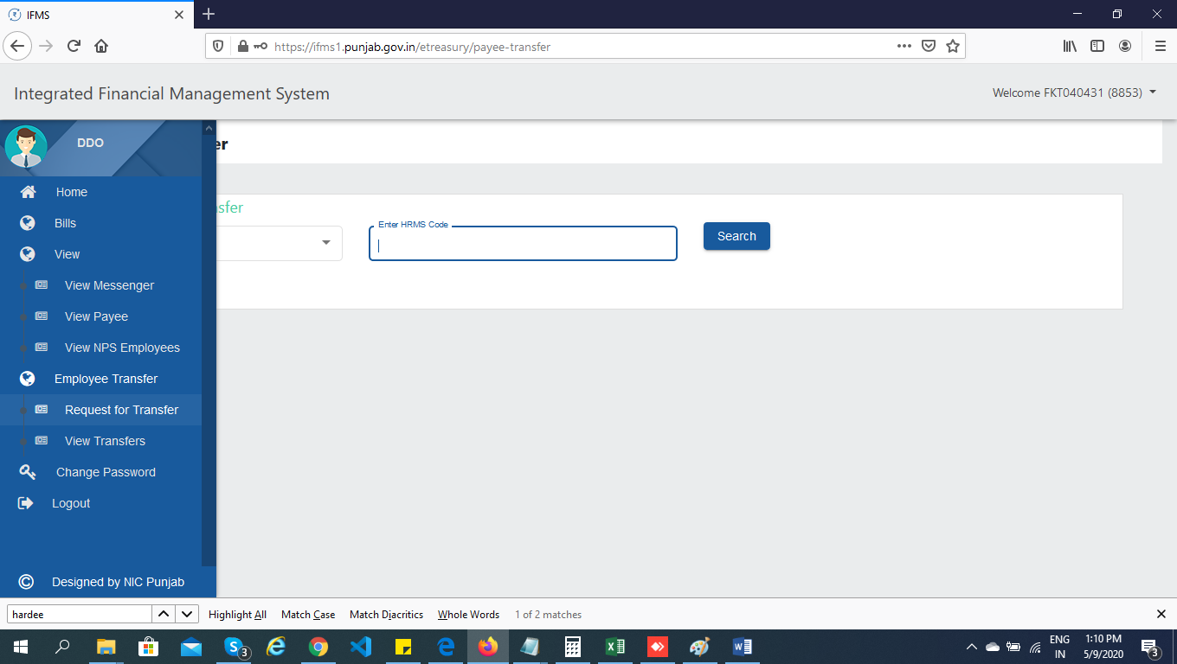

- If HRMS Employee Code not be available as entered, then system will give error message as shown below:
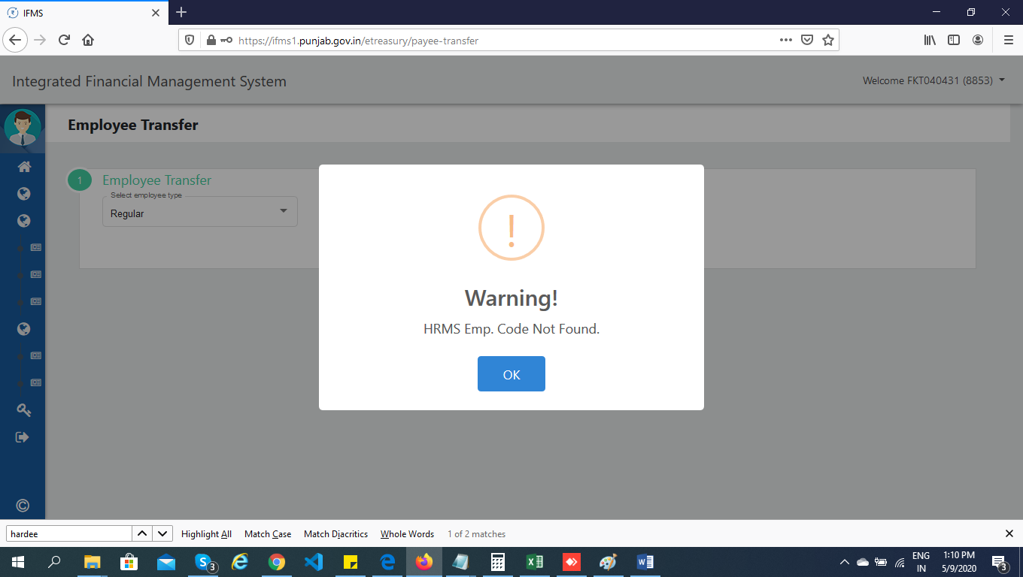

- To Add Payee, login with your clerk id and click on Add Payee link on left menu, it will display screen as shown below:
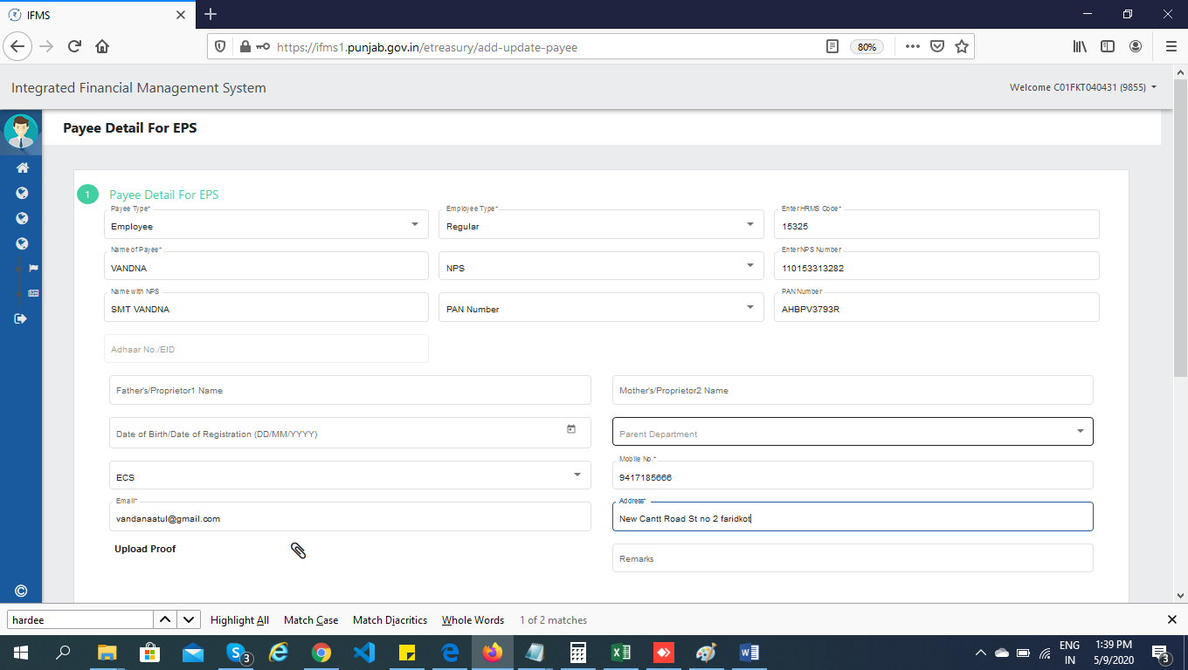

- If system says “Payee already exists” as shown below: 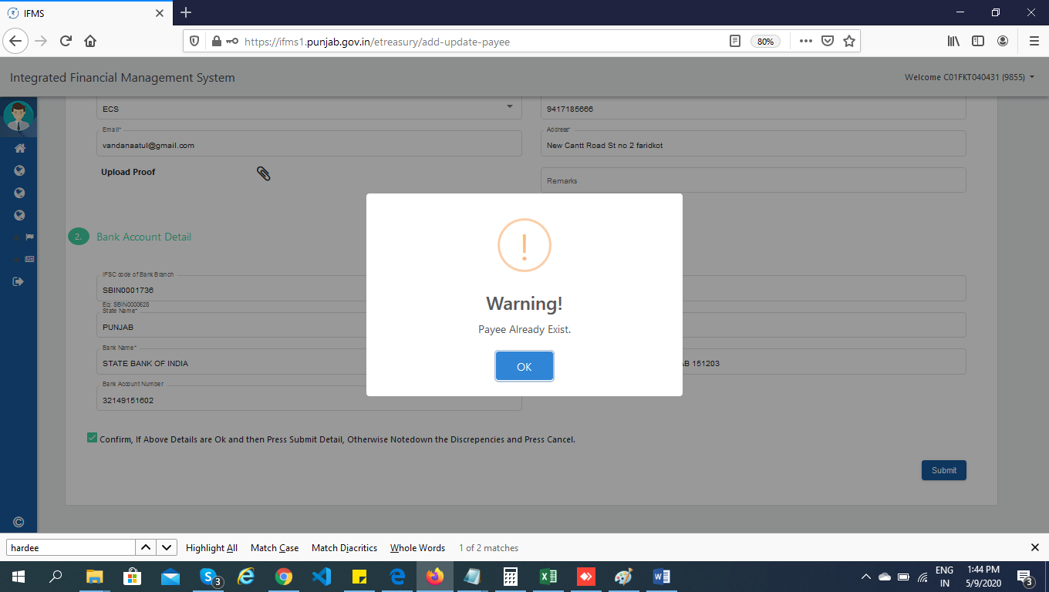

- Please mail the data to helpdesk team at etreasuryifms@gmail.com with screen shot of Payee already exists as per below attached format.

